**Final Year B.Tech. (CSE) – II [ 2022-23 ]**

**Cryptograpy and Network Security Lab**

**PRN: 2019BTECS00015**

**Full name: Shraddha Sanjay Kharat**

**Batch: B1**

**Assignment No. 15**

**Title:**

Snort Intrusion Detection System (IDS)

**Aim:**

To Installing snort**.**

**Theory:**

Snort is referred to as a packet sniffer that monitors network traffic, scrutinizing each packet closely to detect a dangerous payload or suspicious anomalies. Long a leader among enterprise intrusion prevention and detection tools

**Process:**

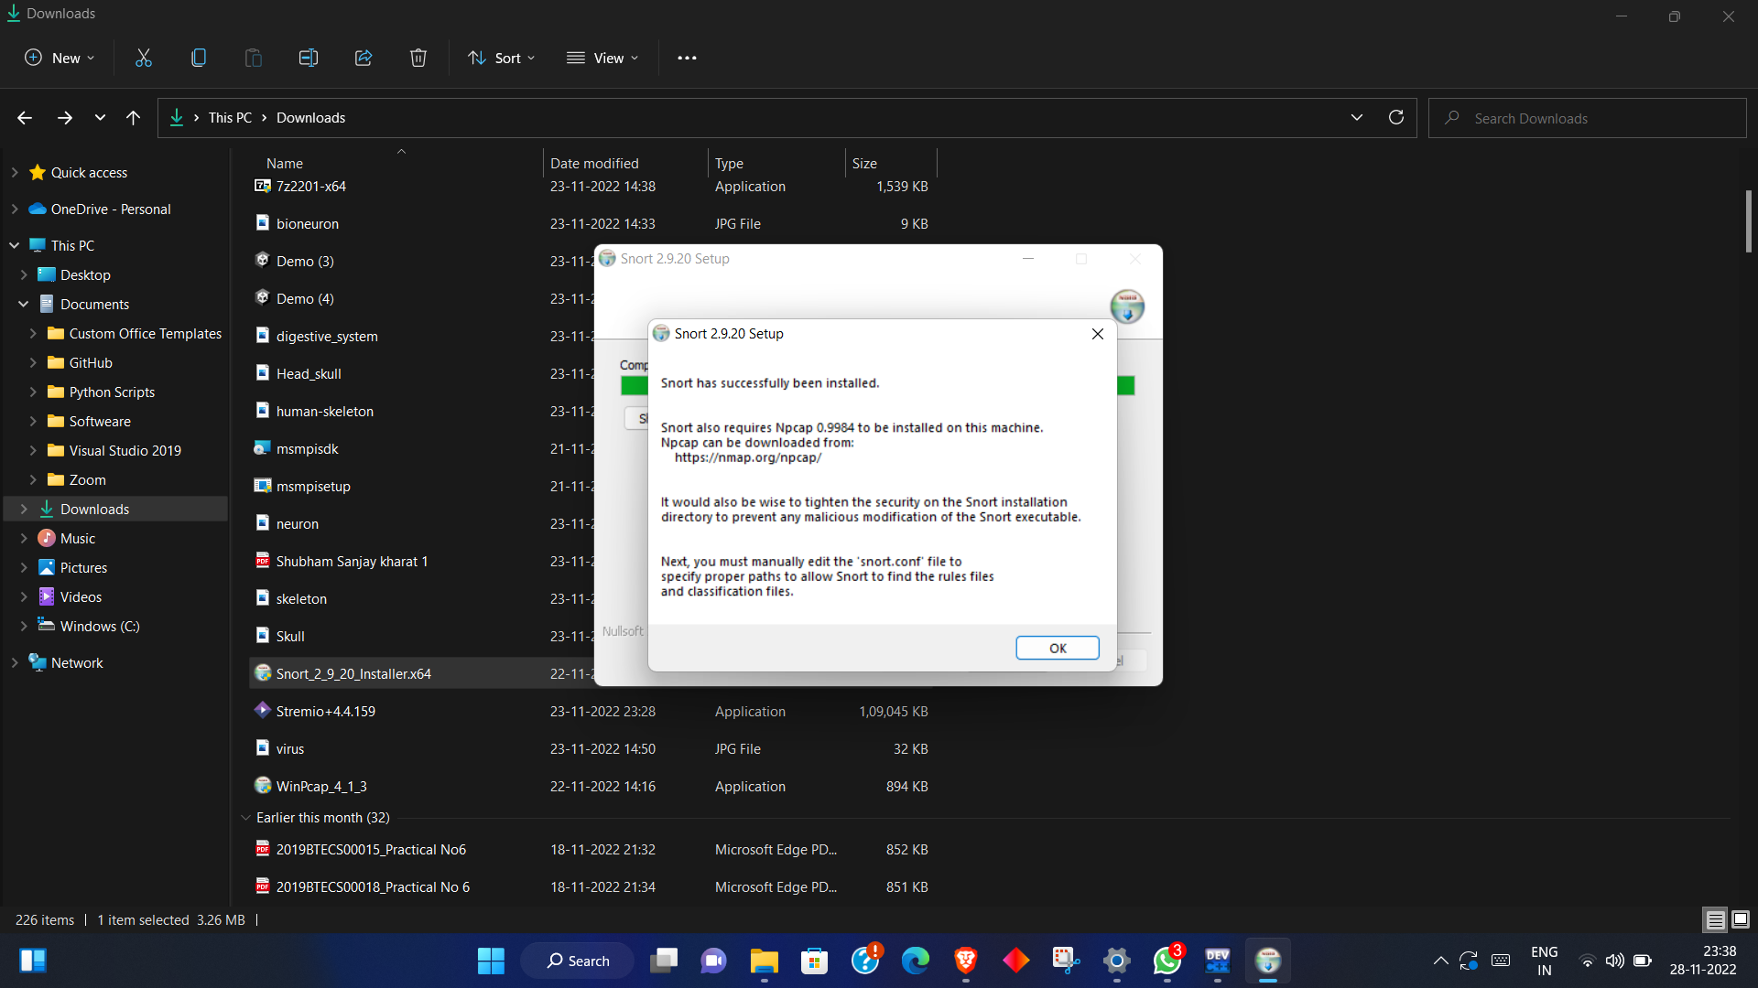

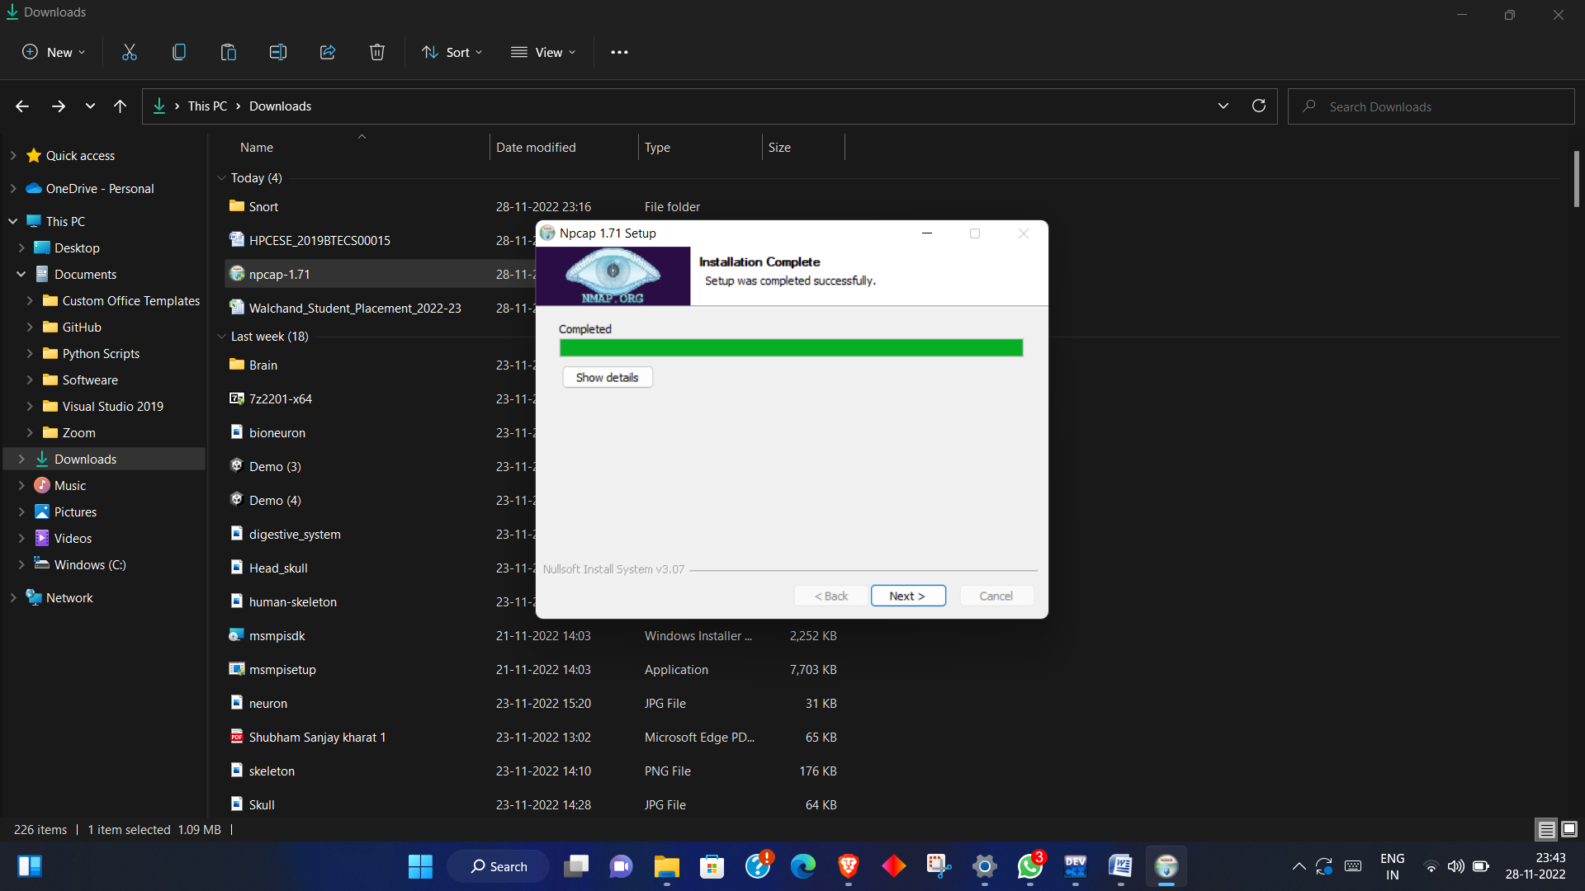

**Output:**

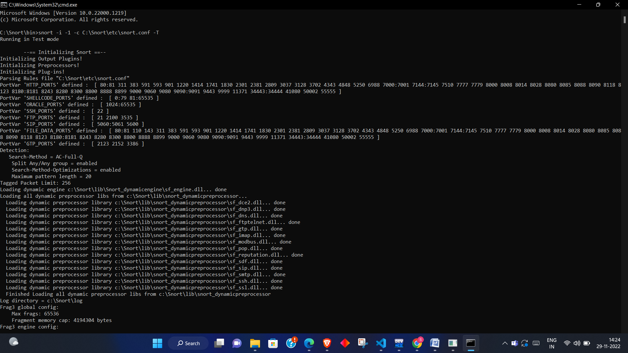

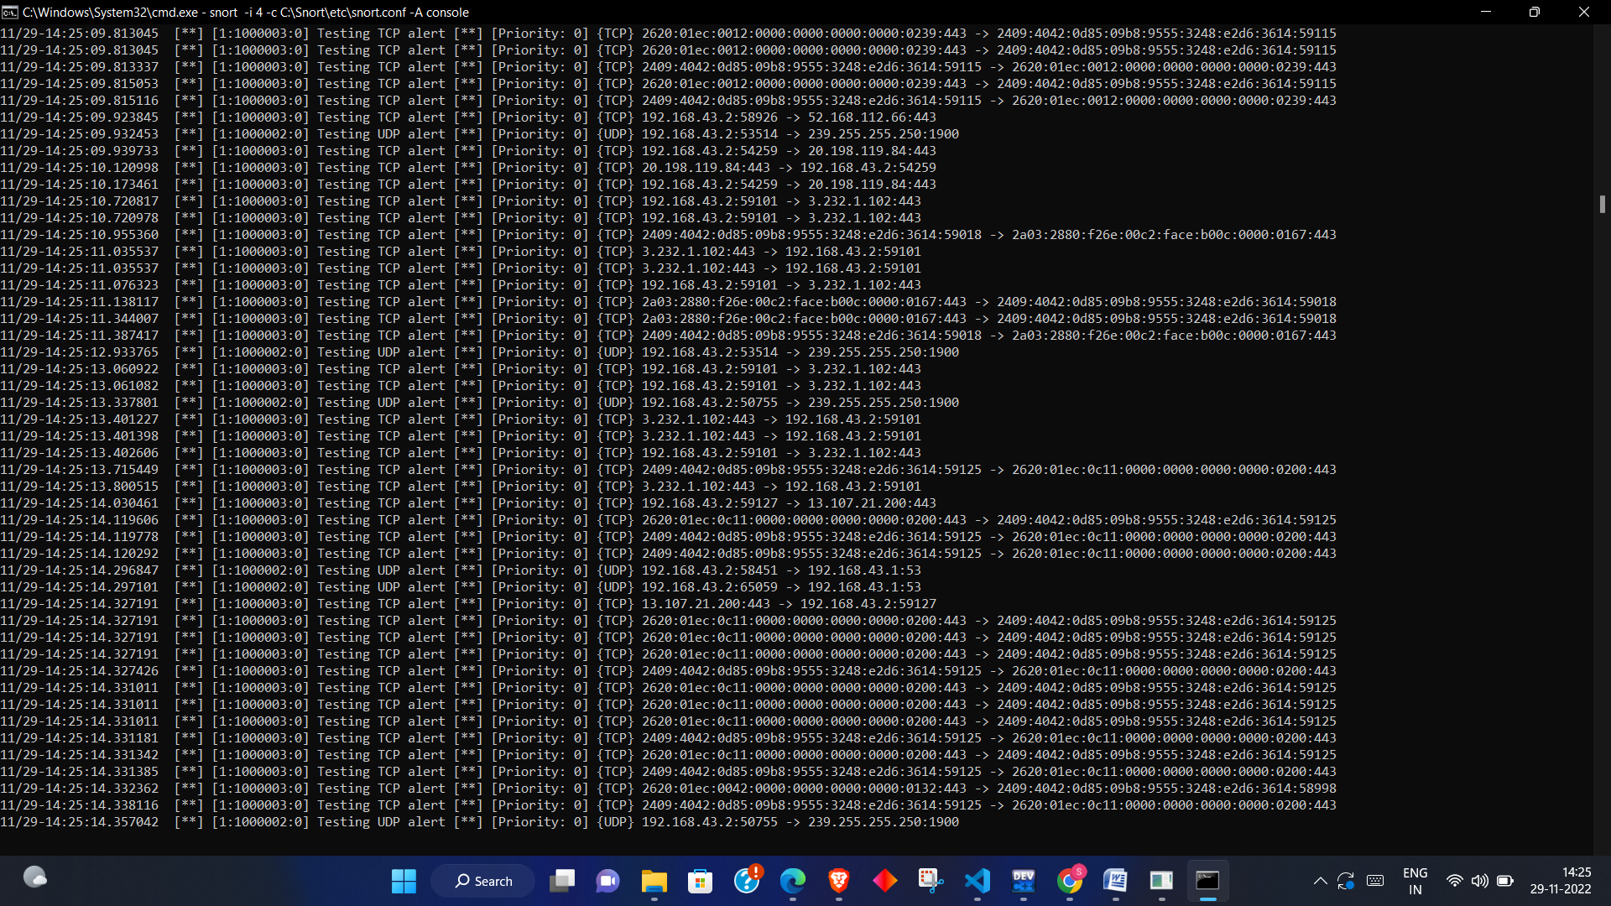

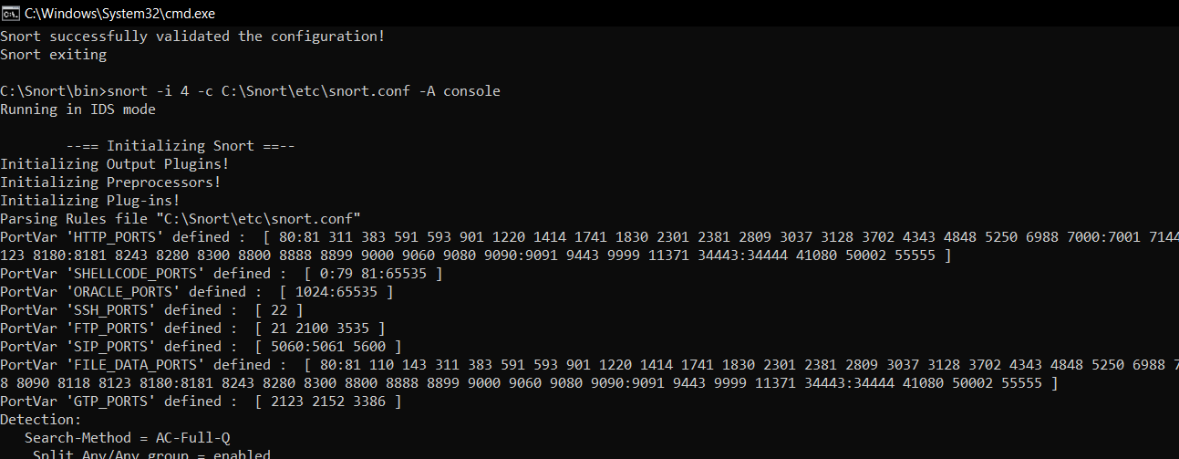

**Conclusion:**

Snort Analyze the traffic and generate the log file

**Cmd –**

**snort -i -1 -c C:\Snort\etc\snort.conf -T**

**snort -i 4 -c C:\Snort\etc\snort.conf -A console**